5th July 2023

Dear Parent/Carer,
Classes for 2023-2024
I am delighted to be able to share the classes and teachers for the academic year 2023-2024. Children will soon have the opportunity to meet their new class teacher and find out about what they will be doing next year.
Class | Teacher
Nursery | Ms Jordan
Reception | Miss Vanstone
Year 1 | Mr M^{c}Carthy
Year 2 | Ms Roberts (new to school)
Year 3 | Mrs Wearing/Mrs Cooper
Year 4 | Miss Johns
Year 5 | Mrs Kiernan
Year 6H (currently 5S) | Mr Heard
Year 6W (currently 5K) | Mr Wareing

Please do not hesitate to contact the school if you have any questions relating to your child’s class next year.
Yours faithfully,
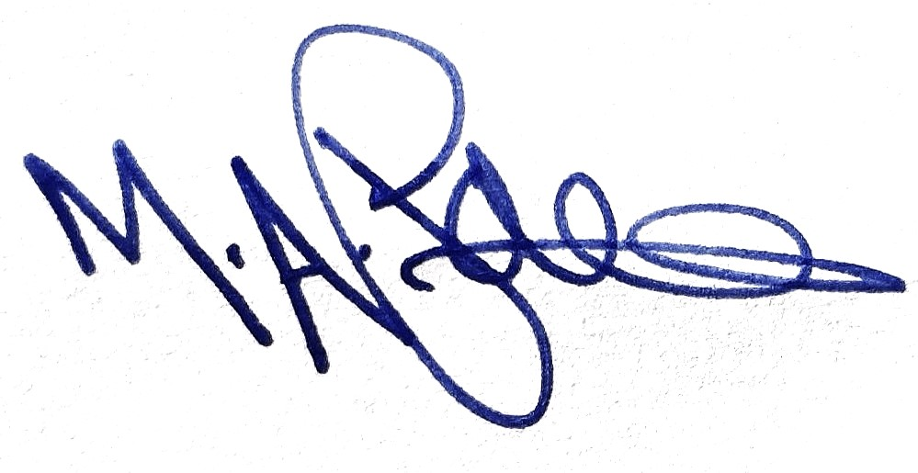
M Paine
Principal

